Topic 9: ‘International conflicts and crises in the 20th century (I) – the two world wars’
Case study：War and Inventions—Medicine
Extended activity: The discovery of penicillin

Study the two sources below, and answer the related questions.

Source A: The following is an American advertisement published in 1944, publicizing the effects of penicillin.
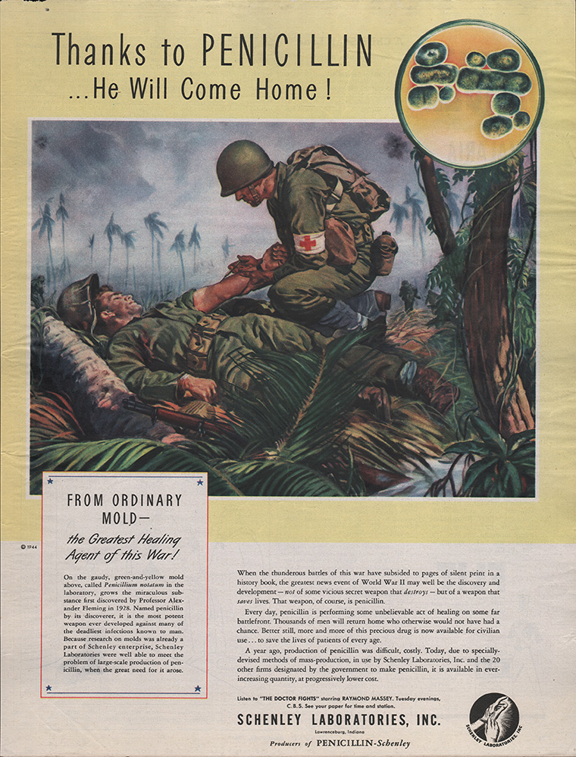

Source B: The following is the speech on the announcement of the winner of the Nobel Prize in Medicine in December 1945.
The extraordinarily good effects of penicillin have been established in a number of important infectious illnesses, such as general blood poisoning, cerebral meningitis, gas gangrene, pneumonia, syphilis, gonorrhea and many others. The present time that the discovery of penicillin and its curative properties in the case of various infection diseases for which this year’s Nobel Prize is awarded, is of the greatest importance for medical science.
Sir Alexander Fleming, Doctor Chain, and Sir Howard Florey. The story of penicillin is well-known throughout the world. It affords a splendid example of different scientific methods cooperating for a great common purpose. Once again it has shown us the fundamental importance of basic research. The starting-point was a purely academic investigation, which led to a so-called accidental observation. With the aid of modern biochemistry, bacteriology, and clinical research, researchers overcame the numerous obstacles, all this work demanded not only assistance from many different quarters, but also an unusual amount of scientific enthusiasm, and a firm belief in an idea. In a time when annihilation and destruction through the inventions of man have been greater than ever before in history, the introduction of penicillin is a brilliant demonstration that human genius is just as well able to save life and combat disease.
Source: https://www.nobelprize.org/prizes/medicine/1945/ceremony-speech/
- According to Sources A and B, identify the effects of penicillin.
Source A：
Source B：
- With reference to Sources A and B, and using your own knowledge, what positive values and attitudes that are worth learning from the discovery of penicillin?

Topic 9: ‘International conflicts and crises in the 20th century (I) – the two world wars’
Case study：War and Inventions—Medicine
Extended activity: The discovery of penicillin
Suggested answer
Study the two sources below, and answer the related questions.

Source A: The following is an American advertisement published in 1944, publicizing the effects of penicillin.

Source B: The following is the speech on the announcement of the winner of the Nobel Prize in Medicine in December 1945.
The extraordinarily good effects of penicillin have been established in a number of important infectious illnesses, such as general blood poisoning, cerebral meningitis, gas gangrene, pneumonia, syphilis, gonorrhea and many others. The present time that the discovery of penicillin and its curative properties in the case of various infection diseases for which this year’s Nobel Prize is awarded, is of the greatest importance for medical science.
Sir Alexander Fleming, Doctor Chain, and Sir Howard Florey. The story of penicillin is well-known throughout the world. It affords a splendid example of different scientific methods cooperating for a great common purpose. Once again it has shown us the fundamental importance of basic research. The starting-point was a purely academic investigation, which led to a so-called accidental observation. With the aid of modern biochemistry, bacteriology, and clinical research, researchers overcame the numerous obstacles, all this work demanded not only assistance from many different quarters, but also an unusual amount of scientific enthusiasm, and a firm belief in an idea. In a time when annihilation and destruction through the inventions of man have been greater than ever before in history, the introduction of penicillin is a brilliant demonstration that human genius is just as well able to save life and combat disease.
Source: https://www.nobelprize.org/prizes/medicine/1945/ceremony-speech/
- According to Sources A and B, identify the effects of penicillin.
Source A：The discovery of penicillin enabled military doctors to use it to heal wounded soldiers
and give them a chance to return home.
Source B：The extraordinarily good effects of penicillin have been established in a number of
important infectious illnesses, such as general blood poisoning, cerebral meningitis, gas gangrene,
pneumonia, syphilis, gonorrhea and many others.
- With reference to Sources A and B, and using your own knowledge, what positive values and attitudes that are worth learning from the discovery of penicillin?

Source A: Scientists were committed to developing penicillin drugs to help wounded soldiers, reflecting the spirit of perseverance and caring.
Source B: Alexander Fleming cooperated with other scientists, conducted researches enthusiastically, and overcame difficulties. They finally discovered penicillin which combated diseases and saved numerous human lives.
Own knowledge: From Alexander Fleming's short story of discovering penicillin, we should learnt to maintain our curiosity and the spirit of perseverance in our learning. Alexander Fleming once found a contaminated dish in his laboratory. He could have easily thrown away the contaminated dish, but out of curiosity, Fleming identified the mold growing in the corner of the dish full of bacteria. He discovered there was a lack of bacteria around the mold. He hypothesized that mold could be used to kill bacteria and finally discovered penicillin.

